Suggested solution to assignment 3
Chapter 4
1. Multiple Choice Questions（Only one choice is correct）
a. If events A and B are independent, then the probability of simultaneous occurrence of event A and event B can be found with:
A. P(A)·P(B)
B. P(A)·P(B|A)
C. P(B)·P(A|B)
D. All of the above are correct
b. A(n) ____________ is the probability that one event will occur given that we know that another event already has occurred.
A. Sample space outcome
B. Subjective Probability
C. Complement of events
D. Long-run relative frequency
E. Conditional probability
c. Two mutually exclusive events having positive probabilities are ______________ dependent.
A. Always B. Sometimes C. Never
d. ___________________ is a measure of the chance that an uncertain event will occur.
A. Random experiment
B. Sample Space
C. Probability
D. A complement
E. A population
Ans: a. D b. E c. A d. C

2. Two randomly selected grocery store patrons are each asked to take a blind taste test and to then state which of the three diet colas (marked as A, B, or C) he or she prefers.
(a) Draw a tree diagram depicting the sample space outcomes for the test results.
(b) List the sample space outcomes that corresponding to each of the following events.
(1) The two patrons prefer different diet colas.
(2) Diet cola A is preferred by at least one of the two patrons.
(c) Assuming that all sample space outcomes are equally likely. Find the probability both patrons prefer diet cola A given that neither of the patrons prefers diet cola C.
Ans: (a)
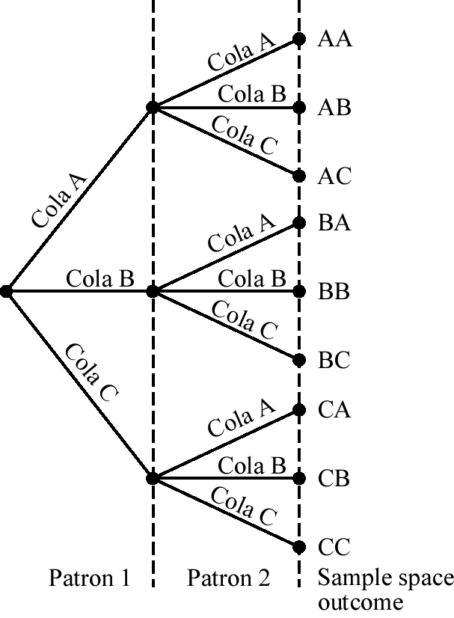
(b) (1) AB, AC, BA, BC, CA, CB
(2) AA, AB, AC, BA, CA
(c) A= “both patrons prefer diet cola A”,B= “neither of the patrons prefers diet cola C”
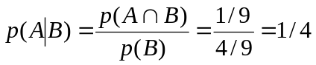
3. In a survey of 100 insurance claims, 40 are fire claims (FIRE), 16 of which are fraudulent (FRAUD). Also, there are a total of 40 fraudulent claims.
(a) Construct a contingency table summarizing the claims data. Use the pairs of events FIRE and 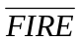, FRAUD and 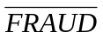.
(b) What proportion of the fire claims are fraudulent?
(c) Are the events “a claim is fraudulent” and “a claim is fire claim” independent? Use your probability of part b to prove your answer?
(d) Are the events “a claim is fraudulent” and “a claim is fire claim” mutually exclusive? Explain your answer.
Ans:(a) Fire 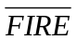 Total
Fraud 16 24 40
24 36 60
Total 40 60 100
(b) 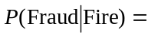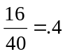
(c) Yes; = P(Fraud)
(d)No. the events “a claim is fraudulent” and “a claim is fire claim” are not mutually exclusive. They have sample space outcomes in common, that is, the probability of the intersection of Fraud and Fire is 0.16 not 0.

4. An advertising campaign is being developed to promote a new bookstore opening in the newest mall development. To develop an appropriate mailing list it has been decided to purchase lists of credit card holders from MasterCard and American Express. Combining the lists they find the following: 40% of the people on the list have only a MasterCard and 10% have only an American Express card. Another 20% hold both MasterCard and American Express. Finally, 30% of those on the list have neither card.
(a).Construct the contingency table summarizing the data.
(b).Suppose a person on the list is known to have a MasterCard. What is the probability that person also has an American Express Card?
(c). Are the events “have a MasterCard” and “have an American Express card” independent? Explain your answer.
Ans: (a) The contingency table could be constructed as follow:
 | MasterCard (M) | No MasterCard (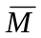) | Total
American Express Card (A) | 0.2 | 0.1 | 0.3
No American Express Card () | 0.4 | 0.3 | 0.7
Total | 0.6 | 0.4 | 1
（b）The probability of a person who is known to have a MasterCard also has an American Express Card, is the conditional probability of a person having an American Express Card given that he/she has a MasterCard:
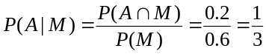
(c) No. Since 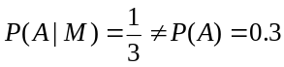.

5. The Wood County sheriff classifies crimes by age (in years) of the criminal and whether the crime is violent or nonviolent. As shown below, a total of 150 crimes were reported by the sheriff last year.
 | Age (in years)
Type of crime | Under 20 | 20 to 40 | Over 40 | Total
Violent | 27 | 41 | 14 | 82
Nonviolent | 12 | 34 | 22 | 68
Total | 39 | 75 | 36 | 150
(a) What is the probability of selecting a case to analyze and finding it involved a violent crime?
(b) What is the probability of selecting a case that involved a violent crime or an offender less than 20 years old?
(c) Given that a violent crime is selected for analysis, what is the probability the crime was committed by a person under 20 years old?
(d) (Optional) Two crimes are selected for review by Judge Tybo. What is the probability that both are violent crimes?
Ans:
(a) P(Violent)=82/150=0.5467
(b) P(Violent or less than 20 years old)= 82/150+39/150-27/150=0.6267 (Additional rule)
(c) P(Under 20 |Violent)= P(Under 20 ∩Violent)/ P(Violent)=27/82=0.3293
(d) P(1st Violent and 2nd Violent)= (82/150)(81/149)=0.2972

6. A department store is considering a new credit policy to reduce the number of customers defaulting in payments. A suggestion is made to discontinue credit to any customer who has been one week or more late with his/her payment at least twice. Past records show 95 percent of defaults were late at least twice. Also, 3 percent of all customers default, and 30 percent of those who have not defaulted had at least two late payments.
(a) Find the probability that a customer with at least twice late payments will default.
(b) Based on part a, should the policy be adopted? Explain.
Ans:
(a) P(default⏐late) 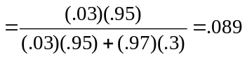
(b) No. Too many paying customers would lose credit.

7. Independently a coin is tossed, a card is drawn from a deck and a die is thrown. What is the probability of observing a head on the coin, an ace on the card and a five on the die? (Hint: There are total 52 cards in a deck.)
Ans: Denote the events of observing a head on the coin, an ace on the card and a five on the die as A, B, and C respectively. Since A, B and C are independent events. Thus,
P(A∩B∩C)= P(A) P(B)P(C)=1/2*4/52*1/6=1/156

